Title of your abstract (Calibri 9pt, bold)

Author 1 ª, Author 2 ^{b}, Author 3 ^{c}, Author 4 ª, Author 5 ^{c}, … (Calibri 8pt )
(underlined author = presenting author)
ª Institute 1, City, Postal code, Country (Calibri 8pt)
^{b} Institute 2, City, Postal code, Country
^{c} Institute 3, City, Postal code, Country
e-mail: xxx@xxx.xx.xx
(e-mail of corresponding author; not necessarily the first author or the presenting author)

Keywords: (Calibri 8pt , one line only)

Abstract Text (Calibri 8pt, single spacing)

Each abstract must state clearly:
• Purpose of the work
• Manner and degree to which it advances the state of the art (novelty, originality)
• Specific results that have been obtained

Authors are asked to submit a one-page abstract in a two-column format. The first column should contain text only, while the second one should contain references, tables, formulas, graphs or photographs. Both text and figures must fit within a page frame of 257 mm (Width) x 165 mm (Height). The column width is 122 mm and the inter-column spacing is 13 mm. Use single line spacing and justified alignment with 8-point Calibri font for the text and 9-point Calibri Bold for the Title only. Pages should not be numbered.

If you use MSWord, please use this template to start writing your manuscript, but make sure that in the page setup the paper size is set to A4 (top and bottom margins are 22.5mm ; left and right margins are 20mm). If you are using Latex or another word-processing program, make sure your manuscript margins and column settings are according to the prescribed rules. Specify page size A4. Please also take into account that there are different margin requirements for A4 than for 8½" x 11" (Letter) to keep the column widths and heights equal!
Figure captions and References should be 8pt Calibri with single spacing.
Figures: Photographs and pictures must be of impeccable grey-scale quality. Figures should be referenced in the text (see Figs 1 and 2). Handwritten lettering on figures is not acceptable. They should have a short caption directly underneath with a concise explanation of the figure or photo.

References: The reference list should be written as in the examples given hereafter for articles in journals [1], books [2], papers in a contributed volume [3], and thesis or unpublished work [4].

IMPORTANT DETAILS FOR ABSTRACT PREPARATION:
- Only PDF-Format is accepted. Please convert your final Word file to Pdf.
- Please resize your figures before importing them to Word, to conform to maximum size of 4 MB pdf file. Resizing is attainable in all common image software (e.g. MS Paint uses Image - Stretch, Adobe PhotoShop uses Image Size as shown in Figs 3 and 4)
- Abstracts should be submitted on-line via nanobioeurope2013.sciencesconf.org. Abstracts submitted via fax or e-mail will not be accepted.
If you run into difficulties or you need additional information, please contact: nanobioeurope2013@itav-recherche.fr
[1] A. Qualtieri, F. Pisanello, M. Grande, T. Stomeo, L. Martiradonna, G. Epifani, A. Fiore, A. Passaseo, M. De Vittorio, Microelec. Eng. 84 (2010) 1435-1438.
[2] E. Borger, Computability, Complexity, Logic (North-Holland, Amsterdam, 1989).
[3] A.K. Lenstra and H.W. Lenstra, Jr., Algorithms in number theory, in: J. van Leeuwen, ed., Handbook of Computer Science, Vol. A (Elsevier, Amsterdam, 1990) 673-715.
[4] A. Rajasekar, Semantics for logic programs, Ph.D. Thesis, Department of Computer Science, University of Maryland, 1989.
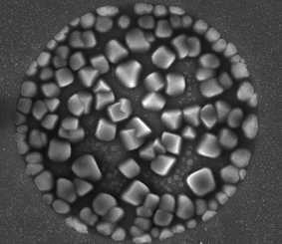 | 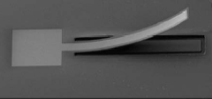
Figure 1. Insert concise explanation of figure 1 here. | Figure 2. Photographs and pictures must be of impeccable grey-scale quality.
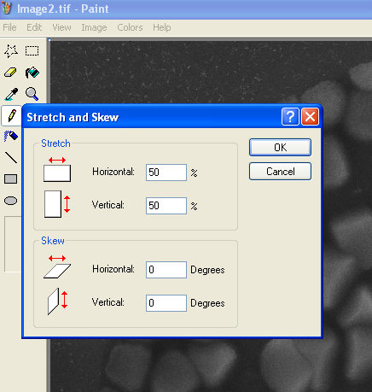 | 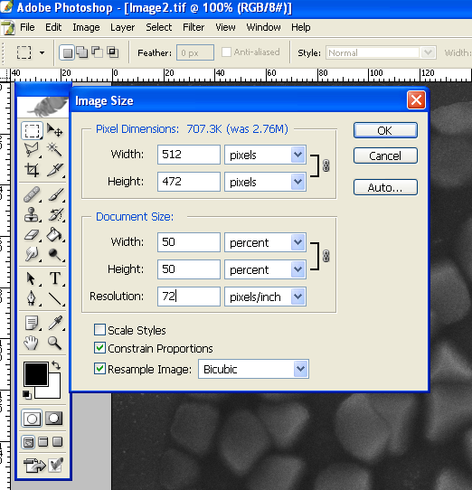
Figure 3. Stretch to 50% in MS Paint reduces the size of your image by a factor 4 (e.g. 1MB becomes 250KB upon saving your image). Use this reduced image to import in Word. | Figure 4. Resize to 50% of original in Adobe PhotoShop reduces the size of your image by a factor 4 (e.g. 1MB becomes 250KB upon saving your image). Use this reduced image to import in Word.

